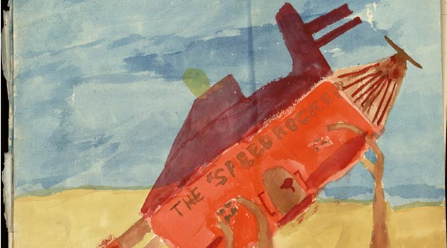

COETZEE & the archive

5-6 OCTOBER 2017

Senate House

ies.sas.ac.uk

### **COETZEE & THE ARCHIVE**

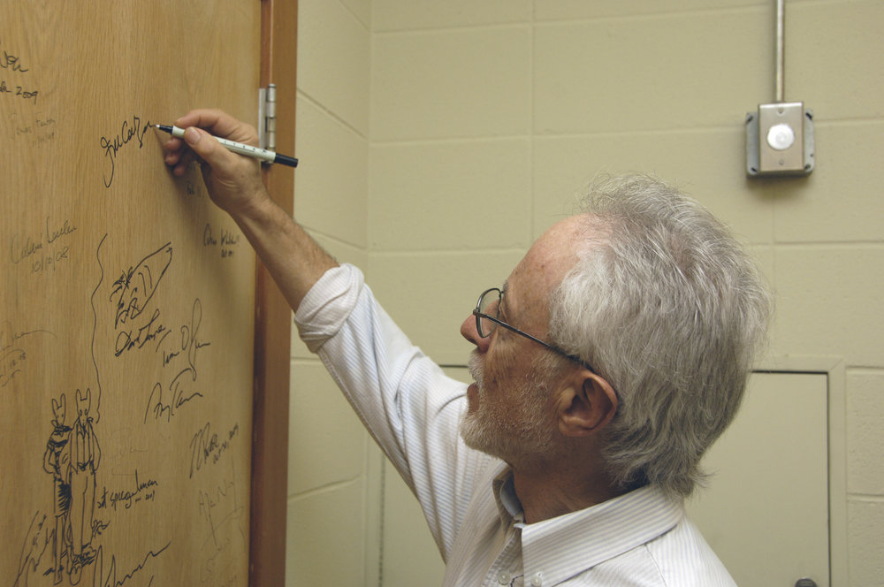

‘… I have been through the letters and diaries. What Coetzee writes there cannot be trusted, not as a fac tual record – not because he was a liar but because he was a fictioneer’ (*Summertime* 225).

What does it mean to be a fictioneer? And what precisely is the relationship between the ‘truth’ of J. M. Coetzee’s works, especially with regard to the life-story of the fictionalised memoirs, and the factual record that lies behind them? How might such a self-reflexive body of work impact upon our reading of archival materials – manuscripts, drafts, letters and diaries?

The recent consolidation in 2012 of the Coetzee Collection at the world famous Harry Ransom Center (HRC), University of Texas - Austin, offers an exciting opportunity for scholars to address anew such fascinating, enthralling, and intractable questions.

This inaugural conference on Coetzee’s archive[1] invites speakers to engage with both the general topic of the archive in Coetzee Studies and with the specific and voluminous materials that have travelled to the HRC to date. What might be considered their ‘origins’, their ‘original homes’? Where were they written, drafted, published, otherwise housed? Where, in other words, do archives ‘begin’, and where might they take us? Can we pinpoint such formations, and what are the implications of such geographies and materialities, theoretically and/or empirically, for the story of a writing life?

Touching upon disciplines as varied as the life sciences, theology and philosophy, South African history and politics, canonical literary intertexts, translation, and engagements with other artistic forms (visual; filmic; sound), Coetzee’s richly curated archive serves as a springboard for further investigations into his published writing and collaborative work. With its numerous multi-lingual and multi-modal resources, it invites a significant expansion of critical scholarship, and asks us to consider questions of wider artistic practices, approach and methodology, genre, theory and creativity.

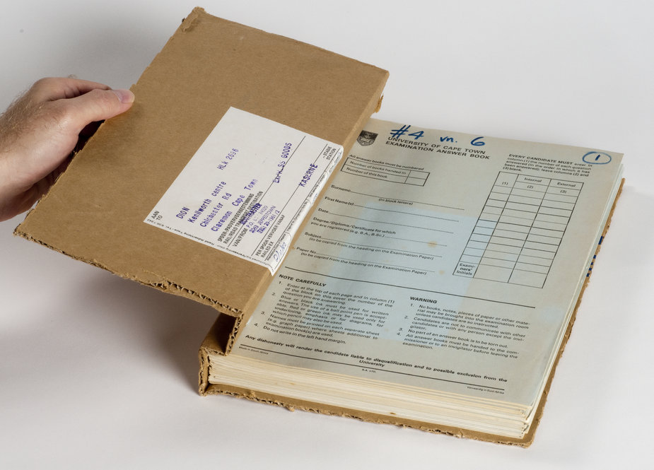

The three images from the Coetzee archives can be found on the website of the HRC. They are repreoduced here courtesy of the Harry Ransom Center, University of Texas at Austin and with the kind permission of J. M. Coetzee.

## Website

<http://www.coetzeeandthearchive.co.uk/>

https://www.ies.sas.ac.uk/events/conferences/coetzee-archive

## Sponsors

- CHASE (Consortium for the Arts & Humanities in the South East). See information on our archival training day for CHASE scholars on 4 October: Chasing the Archives: Exchanges, Encounters, Elisions <http://www.chase.ac.uk/chasing-the-archives/>

- John Coffin Memorial Trust, University of London

## Convenors

[MARC FARRANT](http://www.gold.ac.uk/ecl/staff/farrant-marc/)is a PhD candidate at Goldsmiths, University of London. His current research project consists of a dual author study of the works of Samuel Beckett and J.M. Coetzee. He has published in *Textual Practice*, *The Times Literary Supplement* and numerous other publications, and is a Senior Editor at the online literary website, *Review 31*.   
He can be contacted at [mfarr042@gold.ac.uk](mailto:mfarr042@gold.ac.uk)  
  
[KAI EASTON](https://www.soas.ac.uk/staff/staff30898.php) is Chair of the Centre for English Studies in the School of Arts at SOAS, University of London. She was awarded a Harry Ransom Center Research Fellowship for her work on the Coetzee archives in 2014, and a collection of essays, *Zoë Wicomb & the Translocal: Writing Scotland & South Africa,*co-edited with Derek Attridge, will be published by Routledge in October 2017. Her most recent project is as curator of the exhibition [‘Navigating the War’](http://www.library.georgetown.edu/exhibition/navigating-war-centenary-exhibition-richey-archives) for The Fairchild Gallery, Booth Family Center for Special Collections, Georgetown University, to mark the centenary of Michael Richey, founding director of the Royal Institute of Navigation in 1947, and legendary single-handed transatlantic sailor of *Jester*.  She can be contacted at [ke@soas.ac.uk](mailto:ke@soas.ac.uk)

**COETZEE & THE ARCHIVE**

**Day 1: THURSDAY, 5 October 2017**

08h45-09h15 Registration/ tea & coffee JESSEL ROOM

09h15-09h30 Welcome SENATE ROOM

9h30-10h00 On Location c. 1940

Material Culture & the Archive

SENATE ROOM

*This introductory session offers a brief overview of a major AHRC-funded project that is currently being undertaken in-house by our colleagues and hosts in the Institute of English Studies in collaboration with the Dept of Digital Humanities at Kings and the National Archives at Kew. It addresses issues around actual and digital archives, wartime censorship and propaganda. See: http://www.moidigital.ac.uk/about-project/*

Marc WIGGAM (IES), ‘Senate House, the Second World War, and the Ministry of Information Project’

10h00-11h00 KEYNOTE CONVERSATION

Addressing the Archive

SENATE ROOM

Jennifer RUTHERFORD (Adelaide) (*in absentia*), ‘Curating Coetzee: from Austin to Adelaide’

Shaun IRLAM (SUNY-Buffalo), ‘Summertime Sadness: J.M. Coetzee, Coordinates & the Negation of the Archive

Kai EASTON (SOAS), *‘Buffalo-Leeu-Gamka’* [film screening]

***Tea and coffee***

***JESSEL ROOM***

11h30-12h30 De-Coding Coetzee in London

SENATE ROOM

Rebecca ROACH (KCL), ‘Coetzee’s Digital Archives, or, everything you never wanted to know about machine code’

Peter JOHNSTON (Cambridge): ‘Coetzee Corpus: Data, Visualisations and Bots from the Digital Archive’

*Chair: Marc FARRANT (Goldsmiths)*

***Lunch – SPEAKERS ONLY***

***JESSEL ROOM***

14h00-15h00 Archival Positions & Proliferations

SENATE ROOM

Andrew VAN DER VLIES (Queen Mary), ‘Coetzee, the Archive, and the Politics of the (Non) Position in the 1980s’

Lucy GRAHAM (UWC), ‘Hitler or Christ?: A Note on *The Childhood* and*Schooldays of Jesus*’

*Chair: Michelle KELLY (Oxford)*

15h00-16h00 Archival Survival

SENATE ROOM

Michele CHINITZ (CUNY), ‘Suspended Time in the Archive: Waiting for History and Slow Fiction’

Cristóbal PÉREZ BARRA (Oxford), ‘Following Borges’s Footsteps: J. M. Coetzee’s Biblioteca Personal’

*Chair: Richard A. BARNEY (SUNY-Albany)*

***Tea and coffee***

***JESSEL ROOM***

16h30-17h45 Copyright & Creative Practice

BLOOMSBURY ROOM / G35

Ian GLENN (UCT)*, ‘*Corresponding with Coetzee: The writer and the institution’

Michael CAWOOD GREEN (Northumbria), ‘On Reflection: Coetzee, the Archive, and Practice-Led Research’

*Discussant: Hermann WITTENBERG (UWC)*

***Drinks / snacks for the cinema***

***OUTSIDE G35***

18h00-19h00 Screening of PASSAGES [VHS]

18h00-19h00 PASSAGES

[film screening – VHS]

BLOOMSBURY ROOM / G35

The first documentary on J. M. Coetzee, originally screened on SABC, 1997 [original video 1999]. Directed by Henion HAN, Produced by Cheryl TUCKETT.

See the review from the now archived *SOAS Literary Review*: <http://eprints.soas.ac.uk/9804/1/EASTON.pdf>

19h00-19h30 KEYNOTE CONVERSATION

Dada & Coetzee [film screening]

BLOOMSBURY ROOM / G35

Derek ATTRIDGE (York) and David ATTWELL (York):

‘Revisiting Coetzee: Authorship & the Archives’

*Introduction: Kai EASTON (SOAS)*

**DAY 2: Friday, 6 October 2017**

09h00-10h00 Life Writing - A Roundtable

BRUNSWICK ROOM / G7

Polona JONIK (Sussex), ‘Coetzee’s Life Writing’: Perseverance, Archive, Ethics’

Charlotte TERRELL (Sussex), ‘“I am, by constitution, a writer”: Coetzee's Literary Economies’

David ISAACS (UCL), ‘”Second Thoughts to the Power of n’”: Textual Revision and Confession in *Summertime*’

*Pre-circulated papers and brief presentations*

*Chair: Elleke BOEHMER (Oxford)*

10h00-11h00 Archiving the Academy

BRUNSWICK ROOM / G7

Andrew DEAN (Oxford) Foes no more? The Academy & the Archive

Paul STEWART (Nicosia), ‘In Pursuit of Style: Coetzee Reading Beckett in the Archive’

*Discussant: Shaun IRLAM (SUNY-Buffalo)*

***Tea and coffee***

***JESSEL ROOM***

11h30-12h30 Lessons in the Archives: The Lives of Animals

SENATE ROOM

Richard A. BARNEY (SUNY-Albany), ‘Coetzee, Biopolitics, and the Archive of Impersonality’

Dominic O’KEY (Leeds), ‘J. M. Coetzee’s Animal Turn, Disgrace, and the Putting-to-Death of Driepoot’

*Chair: Sarah PETT (SOAS)*

***LUNCH***

***JESSEL ROOM***

14h00-15h00 The Artist & the Archive

SENATE ROOM

Richard MOSSE, *Incoming* / *Waiting for the Barbarians*

*A presentation by the winner of the Prix Pictet, 2017 on the making of* Incoming*, his recent installation at the Barbican in London, and the influence and inspiration of Coetzee’s* Waiting for the Barbarians on his work*.*

*Introduction: Carrol CLARKSON (Amsterdam)*

15h00-16h00 KEYNOTE CONVERSATION

Censorship & the Archive

SENATE ROOM

Peter McDONALD (Oxford) & Hermann WITTENBERG (UWC)

***Tea and coffee (en route to final session)***

16h00-17h00 Philosophy & the Archive

SENATE ROOM

Jan WILM (Goethe) (*in absentia*), ‘The Archive In/Of J. M. Coetzee’

Marc FARRANT (Goldsmiths), ‘”The Aura of Truth”: Coetzee’s Archive and the Question of Literary Authority’

*Discussant:* *Andrew GIBSON (Royal Holloway)*

17h30-20h00 READING, MUSIC & RECEPTION

CHANCELLOR’S HALL

J. M. COETZEE: a reading from *The Schooldays of Jesus*

Kathryn MOSLEY: guest pianist [selections from Bach, beginning with the *Prelude* from English Suite no. 2 in A-minor

Works by Johann Sebastian Bach (1685–1750)

Kathryn Mosley - Piano

English Suite no. 2 in A minor BWV 807 (1715–20)

*Prelude*

Invention no. 8 in F major BWV 865 (1723)

Sinfonia no. 9 in F minor BWV 779 (1723)

Partita no. 2 in C minor BWV 826 (1726–30)

*Sinfonia*

Prelude and Fugue in G major BWV 884 Well Tempered Clavier Book II (1742)

Prelude and Fugue in A Minor BWV 865 Well Tempered Clavier Book I (1722)

Cantata BWV 22 Jesus nahm zu sich die Zwölfe (1723)

*Mortify Us By Thy Grace* (1922) arr. Walter Rummel (1887–1953)

Cantata BWV 147 Herz und Mund und Tat und Leben (1716 and 1723)

*Jesu, Joy of Man’s Desiring* (1926) arr. Myra Hess (1890–1965)

# Abstracts

Derek ATTRIDGE (York) (film screening) Keynote Conversation with David Attwell on Revisiting Coetzee: Authorship & the Archives.

David ATTWELL (York) (film screening) – Keynote Conversation with Derek Attridge on Revisiting Coetzee: Authorship & the Archives.

Kai EASTON (SOAS, London) (film screening), *Buffalo-Leeu-Gamka*

Richard A. BARNEY (SUNY – Albany) : Coetzee, Biopolitics, and the Archive of Impersonality

This paper examines how the relation of Coetzee’s work to the archive of the 18th century suggests what I call a ‘counter-current’—rather than a full-blown counter-tradition—of impersonality. While some critics have noted the importance of Modernist concepts of literary impersonality (such as T.S. Eliot’s) for Coetzee’s fiction, this paper takes a biopolitical perspective informed by Giorgio Agamben and Roberto Esposito in arguing that impersonality has significantly broader political stakes related both to the way Coetzee has repeatedly engaged with 18th-century texts and to the way the more extensive 18th-century archive contains earlier experiments with techniques of conveying impersonality.

If the Enlightenment served as a crucial historical watershed of ‘the personal’ by articulating modern psychological interiority and individual rights, then Coetzee’s interest in the period is one that critiques what Agamben calls the resulting ‘anthropological machine’—an entire sociopolitical apparatus that has come to distinguish human personhood from nonpersonhood, as well as human beings from animals, with deleterious results for all those who fall outside the purview of ‘the person’. This paper draws particularly on Esposito’s endorsement of the impersonal not as the anti-personal, but instead as that which ‘is situated, rather, at the confines of the personal; on the lines of resistance, to be exact, which cut through its territory, thus preventing, or at least opposing, the functioning of its exclusionary dispositif’. In adapting Esposito’s thesis to Coetzee’s fiction, I argue that Coetzee investigates the impersonal not only by dislocating 18th-century motifs of personality, but also by seizing on those moments in 18th-century texts when emergent elements of impersonality can be identified and amplified.

The first part of the analysis will examine briefly how Coetzee’s fiction, including *Foe*, *Elizabeth Costello*, and the Nobel lecture ‘He and His Man’, has deployed various strategies of the impersonal as a response to the work of Daniel Defoe and Jonathan Swift. The paper’s primary focus, however, will be on the lesser-known corners of the 18th-century archive in order to detect a nascent strand that exhibits palpable elements of the impersonal. The case in point is John Thelwall, a late 18th-century British novelist, poet, and political radical, whose long-overlooked oeuvre has recently received new attention as his texts have slowly begun to emerge ‘out’ of the archive in the form of recent modern editions. (My own work on these texts has focused primarily on library and digital archives.) While in some ways Thelwall’s fiction participates in the legacy of personality by stressing individual feeling and empathy with others, in other ways it establishes a counter-current of impersonality that resonates with Coetzee’s work in several ways. Particularly in the case of Thelwall’s novel *The Peripatetic* (1793), for instance, we can identify three registers of the impersonal. These include: first, a permeability of personal boundaries that generates a mosaic of multiple subjectivities; second, a deflation of traditionally defined human ascendancy in the interest of articulating human-animal commonality; and third, a periodic fungibility of narrative voice that offers the prospect of new relations among both human beings and other species. The presentation will conclude by considering how Coetzee’s relation to the 18th-century archive of impersonality has larger implications for evaluating the relation of an author to archives in general, particularly by displacing the tempting logic of an archive whose disparate elements form a totalizing coherence based on notions of the ‘great author’ or ‘genius’. Not coincidentally, both of those concepts have their origin in the ‘personal’ tradition of the Enlightenment and Romanticism, whose legacy both Thelwall and Coetzee have profoundly challenged.

Michael CAWOOD GREEN (Northumbria): On Reflection: Coetzee, the Archive, and Practice-Led Research

While there is increasing recognition across the academy that the processes of producing creative artefacts may serve as a vital contribution to knowledge, there is less agreement as to how creative practice can be defined as ‘research.’ One commonly agreed criterion however, is the inclusion of some form of critical self-reflection as an integral part of the creative project.

This combination of the act of writing creatively and the act of critically considering that act results in an emphasis on action and process rather than the finished artefact. The meticulous ‘self-archiving’ (20) Attwell identifies as a feature of the material in the Coetzee Collection is, in its way, analogous with the AHRC’s requirement that the reflective exegesis accompanying the creative work in a practice-led project include ‘some form of documentation of the research process’. More importantly, the ‘factual record that lies behind’ Coetzee’s writing speaks to what Haseman and Mafe identify as the importance of ‘emergence and reflexivity in practice-led research’. This they describe in terms illustrated in Coetzee’s manuscripts:

Reflexivity… occurs when a creative practitioner acts upon the requisite research material to generate new material which immediately acts back upon the practitioner who is in turn stimulated to make a subsequent response. Within this looping process authorial control can be fragmented, raising doubts about purpose, efficacy and control. A kind of chaos results and it is from within this chaos and complexity that the results of the creative research will begin to emerge and be worked through (2009: 219).

Following Attwell in his taking ‘a step back in order to look again, this time not as a literary critic would, which is to say the finished works, but at the authorship that underlies them’ (2015:18), this paper will then consider the importance of the archive for that combination of the writerly and the scholarly that makes up practice-led research.

Michele CHINITZ (CUNY) : Suspended Time in the Archive: Waiting for History and Slow Fiction

‘We must each write the history of the world, of our world, from the viewpoint of our self’, the protagonist in an early draft of *Waiting for the Barbarians* says. If this tenet describes the practice of the ‘fictioneer’ it also problematizes the genre of history, as Coetzee identifies this injunction with a logic of historicism that is paradoxically un-self-aware. His answer to the dilemma of writing history and writing the self for the would-be fictioneers of *Waiting for the Barbarians* and *Slow Man* is to try to imagine history while poised at the breaking point of historicism. In this talk I explore what the suspended temporality of the archive can reveal about the processes by which Coetzee articulates and transforms concepts of history and time. Held at the Harry Ransom Center, drafts of *Waiting for the Barbarians* show how the problem of desire becomes a problem of the time of empire, with the inscription of desire eventually absorbed by the narrator’s lapses in consciousness, while the drafts of *Slow Man* rehabilitate a figure at ‘the end’ – the novel’s working title – by slowing him down and offering the changeability of improvisation to the narrative and to ways of documenting history. If, like Attwell, we attend to the evolution of Coetzee’s style, the differences between these novels, written decades and continents apart, give relief to the distinct functions of suspended time in each. Contemplating the reflexivity of the archive, how might the traveling futures of these two novels as operas re-imagine their construction of history according to musical time and current events? By focusing on the temporal dimension of the archive I seek discussion of place and home, migration and nation, in Coetzee’s manuscripts through the discrepant coordinates of space and time.

Andrew DEAN (Oxford) : Foes no more? The Academy and the Archive

There is something of a Coetzee goldrush taking place. Scholars from across the world (myself included) are going to the Harry Ransom Center (HRC) to stake their claims in this rapidly developing area of criticism. And the fruits of this labour are already emerging: publications and conference papers that draw on the archive now include David Attwell’s *J. M. Coetzee and the Life of Writing: Face-to-Face with Time* (2015), John Bolin’s recent articles, and numerous conference papers. Yet, for those of us who have been out to the HRC, what is surprising is not the meticulous order of the materials, or the evidence of enormous artistic enterprise, but rather a persistent sense that the papers may themselves be a self-reflexive intervention into the author’s reception.

In this paper, will trace two particular moments in which the archive positions its readers at the limits of critical practice. Focusing first on Coetzee’s correspondences with several critics in the 1980s, I will show him recruiting critics for his own ends. Turning then to consider the history and contents of an early sketch of ‘The Vietnam Project’, I will demonstrate how Coetzee flaunts an almost obscene moment of personal revelation, one that achieves both biographical and artistic outcomes. I argue that what we as researchers are confronted with, at the limits of critical practice, is our desire to occupy some position outside the fray. This, we find, is itself connected to Coetzee’s own long-running skepticism of the capacities of literary criticism itself – the archive begins to speak in the language of his own concerns across the oeuvre. Rather than getting past Coetzee, then, we are faced with reasons to engage in a reformulation of criticism, potentially in the terms of weakness – ‘a jocoserious abnegation of big-phallus status’, as Coetzee put it in ‘Erasmus: Madness and Rivalry’.

Marc FARRANT (Goldsmiths, London) : ‘The Aura of Truth’: Coetzee’s Archive and the Question of Literary Authority

‘We possess *art* lest we *perish of the truth.’* – Friedrich Nietzsche

The question of authority in J.M. Coetzee’s works is an intractable one for scholars. Authority is tied to the problem of embarkation, or disembarkation, of the before and after of the literary work: how does one get from ‘where we are’, asks the narrator of *Elizabeth Costello,* ‘which is, as yet, nowhere, to the far bank’? In Coetzee’s writings on secular confession it is not starting but ending that becomes a problem; when exactly does the narrative satisfactorily coincide with the life? As the question of truth, the authority of the truth, becomes ever increasingly prescient in the later writings this paper considers the archive in light of the consequent problematising of literary authority. In Coetzee’s second memoir, *Youth,* the young John, who is seeking to embark on the perilous enterprise of literary fiction, poses the necessity of what he terms ‘the aura of truth’. For this, the verisimilar methods of the mimetic arts – and their underlying correspondence to what is elsewhere termed ‘truth to fact’ – will not suffice.

Coetzee’s point of embarkation to locate this aura – the start of an academic career that begins shortly after the events of *Youth* – will focus on the work of Samuel Beckett. Coetzee’s stylostatistical analysis of Beckett’s *Watt* is exemplary as an early work of the digital humanities that undermines the fundamental premise of the digital humanities; what Coetzee identifies as the ‘general positivism’ that marks any attempt to quantitatively delineate literary meaning. Taking as a cue the recent ‘archival turn’ in Beckett studies, this paper seeks to transpose Coetzee’s diagnosis of a ‘metaphor of linearity’ from the context of mathematical positivism to that of historical positivism. This transposition is licensed by Coetzee’s first fiction, *Dusklands* – conceived shortly after the thesis on Beckett – which satirises the world-historical effects of scientific positivism as it manifests in the form of the military-industrial complex. Later this same parallelism arises in the portrayal of ‘the great rationalization’ of the academy in *Disgrace* as emblematic of the problems facing the construction of historical truth in post-Apartheid South Africa. To what extent, then, does literary truth as *auratic* – with Walter Benjamin’s sense of the aura of the work of art in mind – undermine the positivist authority of biographical/historical, genetic, or empirical approaches to the archive?

Ian GLENN (UCT): *‘*Corresponding with Coetzee: The Writer and the Institution’

In my paper, I would focus on three issues, with most of my energy going to the first two questions of the writer and the institutional archive.

1) What is the status of Coetzee emails kept in the UCT archive of emails or of any email records of his at other universities? Will they be, should they be, available for future researchers? What are the ethics of such documents? Who owns emails as a sender or recipient of Coetzee emails?

2) Coetzee, the institution, and the politics of the de-colonized curriculum. Given the recent debates about curriculum and de-colonization at UCT and more widely, and attacks on Coetzee by Coovadia and others, how is one to assess his role in the politics of the South African academy? This section will focus on Coetzee’s intellectual contribution to the development of African Literature at UCT and on his nomination of Mazisi Kunene for an honorary doctorate in the 1980s.

3) Coetzee and his translators. What light does Coetzee’s correspondence with various translators shed on his view of his own work and his interpretations of it? How much of this work is or should be available? This section will focus on Coetzee’s correspondence with one of his most important French translators, Catherine Lauga-Du Plessis.

Lucy GRAHAM (UWC) : Hitler or Christ?: A Note on *The Childhood* and *Schooldays of Jesus*

This paper uses the spark of an idea recorded by Coetzee in the notebook of *In the Heart of the Country* to read aspects of *The Childhood* and *Schooldays of Jesus*, which were published four decades later. Apart from exploring concepts of idealism and totalitarianism in Coetzee's two latest novels that are suggested by this note, the paper aims to show the rhizomatic shape of ideas within the notebooks and manuscripts, where ideas in one notebook or manuscript give rise to and become interconnected with ideas and characters in later novels.

Shaun IRLAM (SUNY – Buffalo) Summertime Sadness: J.M Coetzee, Coordinates and the Negation of the Archive

In this paper I explore the relationship between writing and place as it pertains to Coetzee’s career, drawing from his own work for guidance. In particular I read a chapter from Coetzee’s life that has received no coverage in his own *Scenes from Provincial Life*. While his years in Austin, Texas as a graduate student are memorialized in ‘Meat Country’ and elsewhere, a remarkable silence surrounds the four years of his first academic job in Buffalo, New York. It is alluded to in only the most oblique way in *Summertime*. This silence is all the more surprising, given the anecdote that this is where *Dusklands* and John’s writing career were spawned and given, too, the fact that Coetzee’s writing career would have had a very different profile had he not been denied residency in the United States and therefore forced back to the South African academy.

Coetzee’s writing career begins on 1 January 1970 at 24 Parker Ave, Buffalo NY 14214. The very particularity of this spatio-temporal moment seems also eerily and negatively consolidated by the imagination that then emancipates itself so thoroughly from this moment and venue to transport itself from the frigid Buffalo winter to the arid expanses of Namaqualand and to float effortlessly across the centuries to the 1760s. The writing wrests itself free from any determinate time, place, origin and context, even from the historical life of its author, to enter that strange immortality called Literature. This inverse relation to the coordinates of autobiography, history, geo-political specificity seem to evince the signature of literature, this ‘negative capability’ that measures the weight of the writer’s historical burden as well as the vigor of his imagination.

If Coetzee speaks often of ‘negative capability’ as the capacity of an author to transcend his/her own ego in order to inhabit the worlds of others, we might assume that this applies a fortiori to his / her historical and geo-political co-ordinates. As much as it is driven by a desire to shed one’s own co-ordinates to inhabit those of others, it is equally motivated by a shuddering from history, a wish to emancipate oneself from a history too painful to bear, too disturbing to face steadfastly as Elizabeth Curren finds she must in *Age of Iron*. The figure of shuddering pervades Coetzee’s work as the symptom of refusal and recoil and it is this gesture that deserves a closer reading as a response to place, ‘this place being South Africa’ (*Disgrace*).

Finally, ‘Summertime sadness’ is the voice of *Summertime* that marks nostalgia through its negation, that says of the past, from *Country* to *Disgrace*, “These are poems I could have written myself, but did not, because, I thought, it is too easy” (IHC 127) or, “Yes, I am giving [it] up” (*Disgrace*, 220). The singularity of Coetzee’s ‘summertime sadness,’ is that it does not embrace an autumnal melancholy, but rather, that it commemorates the past while not succumbing to its siren song. My presentation engages with Coetzee and the archive through a reflection on the dialectical tensions between history and literature.

David ISAACS (UCL) : ‘Second thoughts to the power of n’: textual revision and confession in *Summertime*

In this paper, which will draw on research I undertook in 2016 at the Harry Ransom Center into the genesis of *Summertime* (2009), I will reconstruct the processes of that book’s composition and, through thus identifying and close-reading some of Coetzee’s habits of revision, will seek to shed light on his conception of confession.

For Coetzee, confession is often a matter of textual revision. Secular confession, he has argued, with no authority to appeal to and thus no absolution possible, can no longer as it once did ‘lead to that end of the chapter whose attainment is [its] goal’. Instead, once having confessed, the confessor must consider the impurity of her motives for doing so, must subsequently confess to that impurity, and must do so again and again. Confession thus becomes an interminable spiral of revision and re-revision. An ethical text is one that seeks to mime this process of perpetual revision, and which ‘as one of its habitual motions glances back sceptically at its premises’; an unethical text is a different kind of revisionary text, one that seeks to forcefully write over reality and fix its subject in a ‘final form’ – to end the chapter.

It is surprising, then, that in *Summertime* Coetzee has written over the reality of his own life to such an extent that his mother is dead at a time when she was alive, and his first wife and children never existed: I will attempt to account for that dissonance. I will argue that Coetzee deliberately leaves traces of his revisions and anxieties in the published text; that he revises revision into the motion of his prose; that he allows his authorial doubt, in fact, to become the book’s form – always self-questioning, always looking back, always imagining a better version of itself. In doing so, I will conclude, he constructs a text whose true form exists in an unreachable future and which thus constitutes just one more stage in the interminable spiral of confession that his entire published output represents. What *Summertime* confesses to is the impure motives of autobiography which it enacts: the very fact of its forceful overwriting of reality.

Peter JOHNSTON (Cambridge): Coetzee Corpus: Data, Visualisations and Bots from the Digital Archive

One of the principal obligations placed upon curators and users of archives would appear to be that the work they undertake should be maximally representative of the archive’s purported subject; in other words, while the many and likely contradictory elements that comprise a given subject may resist a totalising representation, some ‘true essence’ of the subject is nevertheless faithfully and impartially embodied. For the curator, on the one hand, the selection of artefacts is as much an art as a science, in the sense that subjective preferences concerning the criteria for inclusion necessarily allow for the potential intrusion of bias. For the user of the archive, on the other, the significance accorded to each artefact may vary according to the nature of the research being undertaken, resulting in a further degree of separation between the output of that research and the ‘truth’ of the subject.

All the while recognising the categorical impossibility of representing without bias the ‘true essence’ of anything so complex as a human being – author or otherwise – this paper seeks to shed some meagre light on a more objectively ‘essential’ J M Coetzee through the use of data, computation, and pseudo-random processes. The paper begins with some general reflection on a corpus-based approach to Coetzee’s writing – both published and unpublished – and providing graphic visualisations of certain trends in the data. Subsequently, it will introduce and demonstrate a computer program that can be ‘trained’ on specific subsets of Coetzee’s writing in order to produce, by means of a stochastic process, sentences that are in some sense characteristically ‘Coetzeean’. Through presenting and contextualising examples of the output of this ‘Coetzee Bot’, the paper will conclude with some further questions about how this process might enable us to consider the concept of the archive anew.

Polona JONIK (Sussex): Coetzee’s Life Writing: Perseverance, Archive, Ethics

‘I want to live. As every man wants to live. To live and live and live. No matter what’. The Magistrate, in J. M. Coetzee’s Waiting for the Barbarians, thus voices an insistent theme in his work, the desire to endure, to continue, to live on. In *In the Heart of the Country*, it is the near-silent injunction of Magda’s inner voice: ‘Prolong yourself, prolong yourself, that is the whisper I hear in my inmost’. It marks Michael K’s enduring fight to live on the edge of death. Even the brutality of the life of immigrants Simon and David in *The Childhood of Jesus* and *The Schooldays of Jesus* serves as a testimony to the will to persevere. Such characters serve as conceptual personae for varied modes of endurance, as well as forms of subjectivity that are riven or subtracted to the seeming bareness of a homo tantum. They point, following Elizabeth Grosz, to an ethics of ‘imperceptibility’, always on the brink of becoming mere survival (an “an-ethics”), an ethics that does not eschew physical forces or impersonal affects in the name of rational self-interested choice or mutual recognition, but takes as its terrain the impermanent corporeal and material investments. Yet in works like *Boyhood* or *Summertime*, Coetzee offers a series of notoriously autobiographical characters, ones who perpetually tempt us to ‘recognize’ Coetzee in the text. As such, they have us question the relation of literature and life, including how the archive of Coetzee’s own experiences and intellectual involvements might have shaped his writing. In this paper, then, I will explore some of the ethical and philosophical implications of how these two notions of ‘life’ (as persevering life and as autobiographical life experience) in Coetzee’s work might intersect. How are the avatars of ‘Coetzee’ in his fictionalised memoirs also subject to the forces of depersonalization, non-recognition, if not bare survival as are his figures of persevering life? How might his work be said to present a double ‘life’-writing? To do so, I will focus on key instances from his novels, as well as the work of Freud, Spinoza, Deleuze, Butler, Wilm, Sharp, and Grosz. This paper will be a part of my dissertation, An Ethics of Endurance: Beckett, Kristof, Coetzee.

Peter McDONALD (Oxford) : Keynote conversation on censorship & *Waiting for the Barbarians* with Hermann Wittenberg

Dominic O’KEY (Leeds): J. M. Coetzee’s Animal Turn, Disgrace, and the Putting-to-Death of Driepoot

This paper will consider how J. M. Coetzee’s animal turn – his developing public concern with animal rights, animal welfare and vegetarianism in the years surrounding the millennium – is thematically and formally mediated by *Disgrace* (1999) and *Elizabeth Costello (*2002). Written during the same period of Coetzee’s career, each text presents its own particular “literary thought-experiment” (Mulhall 2009, Clarkson 2009, Barney 2016) into the relationship between the novel, language, and animality. Crucially, though, in *Disgrace* Coetzee puts these problematics to work within the logic of the lyrical realist novel, while *Elizabeth Costello* turns to metafiction. In this paper I will therefore ask what is at stake in this stylistic shift from realism to metafiction, how this informs ongoing debates surrounding Coetzee’s ‘late style’ (Murphet 2011, et al), and what this means for Coetzee’s deliberate mobilisation of questions concerning animal ethics. In doing so I will argue that *Disgrace* and *Elizabeth Costello* are two formally distinct but thematically interrelated ‘creaturely archives’. That is, both texts archive particular affects associated with a certain species-anxiety surrounding the intractability of anthropocentrism. In this sense Coetzee uses both novels to interrogate the immanent anthropocentrism of the novel, and indeed tests the novel’s formal limits as its logics open up but also foreclose questions pertaining to human and nonhuman life. While not drawing specifically on the materials contained at the Harry Ransom Center, then, I am interested in reflecting on precisely what Coetzee’s texts might be said to archive.

Cristóbal PÉREZ BARRA (Oxford): Following Borges’ footsteps: J. M. Coetzee’s Biblioteca Personal

The publication of J. M. Coetzee’s Biblioteca Personal, begun in 2013 and completed in March, is an extraordinary event. It is a twelve-volume library of literary works selected and introduced by him; eleven of which are devoted to the prose of equal number of writers, while the remaining volume is a poetic anthology of 51 authors. Although Coetzee has not provided a general prologue for the whole collection, he read in Buenos Aires and Bogotá an unpublished lecture called ‘The Idea of a Personal Library’, which partly serves this purpose. Never before has a writer of his stature endeavoured on a project of this scale.

One unique feature of this collection is that it was published in Buenos Aires, in Spanish translation. It has been inspired by Jorge Luis Borges’ Biblioteca Personal (1985-86), an author who has contributed to Coetzee’s literary formation. I will delve into the library of the Argentine writer, and also into the underlying concept of archive, as understood by Roberto González Echevarría. One must also remember that Borges was a librarian himself, one who had a lifelong interest in book history, as studied by Alberto Manguel. I will explain how these concepts come to light in Borges and Coetzee’s works.

Unlike Borges, Coetzee wrote the introductions for his collection with a long provision of time and in full possession of his intelectual and physical powers. Thus, every piece seems to be backed not only by a profound rereading of each work, but rather by one of each author’s whole oeuvre, and of most of the scholarly works written about him or her. Furthermore, they are enhanced by a profound knowledge of disciplines such as history, psychology and medicine, but also, and most of all, by his own experience as a critic and writer. When all the introductions have been read, one’s understanding of Coetzee’s craft as a wordsmith is amplified: throughout them, one always sees Coetzee the writer at work. Consequently, if Borges’ is to be understood as a reader’s personal library, my interpretation is that Coetzee’s is – first and foremost – a writer’s personal library.

Rebecca ROACH (KCL) : Coetzee's Digital Archives, or, everything you never wanted to know about machine code

Before J. M. Coetzee embarked on a career as a scholar and writer, the South African-born writer was a computer programmer in the early years of the industry’s development, working on one of the most advanced programming projects in Britain in the mid 1960s. While readers of Coetzee may be familiar with these experiences from their description in his second ‘fictional autobiography’ *Youth* (2002), Coetzee’s role on the Atlas 2 project and his sustained interest in computing across his academic and literary career have been largely ignored by researchers to date.

This is, I hope, about to change, thanks to Coetzee’s digital archives being made available to scholars. Held at the Harry Ransom Centre at the University of Texas, Austin, Coetzee’s print archives stretch to 58 linear feet of material and are regularly consulted by researchers. In the last few months and thanks to the Center’s digital archivists, his born digital materials including a computer tape reel, over 100 floppy disks and various email correspondence, have also been opened for research.

I was lucky enough to get a sneak peak. In this talk, I want to briefly discuss the scope of this archive, and some of the challenges and opportunities it offers too researchers, while also attempting to provide a digital book history of Coetzee’s ‘other career’. Providing an example of current practice around the preservation and making accessible of a born digital collection, Coetzee’s archive also represents an important limit case, stretching as it does across 60 years of digital innovation and thanks to the profound implications it has for our understanding of his aesthetic project.

Paul STEWART (Nicosia): In Pursuit of Style: Coetzee Reading Beckett in the Archive

The influence of Samuel Beckett on Coetzee has frequently been described as one of ‘style’. This paper attempts to understand what is meant by ‘style’ and how this is connected to matters of authority and authorial control within Beckett’s texts.

Throughout the thesis, Coetzee is keen to identify aspects of Beckett’s texts which appear to be ‘stylistically free’ insomuch as they are free from the demands of various contexts, such as plot and characterisation. By doing so, it might then be possible to isolate ‘free choices and point to characteristics of the ideal contrast we call “Beckett’s style”’. (117) Coetzee’s phrasing here, my paper argues, is of crucial importance as the search for ‘Beckett’s style’ is shadowed by situating control for the text within the author himself in the manner of ‘a personal stylistic preference’ (120 my emphasis). From the outset, Coetzee claims that his thesis is not concerned with ‘the views of the historical Samuel Beckett’ and he further warns against the view of Leo Spitzer that a study of style will lead to uncovering a ‘creative principle which may have been present within the soul of the artist’. (16) However, this paper argues that Coetzee’s thesis consistently, if obliquely, returns to a logic that could be seen as leading precisely to the historical Samuel Beckett as ultimate authority over the texts.

Charlotte TERRELL (Sussex) : ‘I am, by constitution, a writer’: Coetzee’s secretaries, authors, writers, and storytellers

Elizabeth Costello’s claim that she is a ‘secretary of the invisible’ has by no means been overlooked, but this paper argues that the inference of secretarial labour has not yet been adequately worked over to allow it to be put to bed. The secretary frames issues of authorship, reading, as well as the technical and material production of writing.

In *The Good Story*, Coetzee tells us that he rows ‘against a certain tide’ when it comes to the act of writing: he does not believe that writing fiction is a dialogic process. The secretary, then, like Coetzee’s array of fictional counterparts (Costello, JC, the Coetzee of *Youth* and *Summertime*) is perhaps a culturally inflected fantasy of authorial dialogism. Coetzee’s meticulously arranged archive, too, implores us to take up a line of questioning about the ideological institution of the author versus the literary ideal of the solitary writer.

Coetzee’s archive has, indeed, revealed an important change in the material composition in his writing process: *Slow Man* (2005) marks the transition from handwritten to computer-typed drafts and, concurrently, this is the point at which Coetzee stopped using notebooks as a means for daily reflection on, and correction of, his work. How, this paper asks, does the move away from the notebooks alter the tone and frequency of interventions by the authorial voice which mediates the writing process?

Drawing on these insights afforded by the archive, as well as the work of Sarah Brouillette on the creative economy, this paper will tracing contemporary debates about authority, authorship, and their relationship to material and commercial forms of authorial production. Forging a homology between these theoretical and literal contexts will permit an exploration of the archive as a site both of culturally ratified authorship and the deep literary history of writing as an isolated, solitary activity.

Jan WILM (Goethe) (*in absentia*): The Archive In/Of J. M. Coetzee

J. M. Coetzee’s archive at the Harry Ransom Center in Austin is now a magnet for scholars, and is reshaping ideas about what constitutes this writer’s oeuvre. The talk reads Coetzee’s archive alongside the published works, and via ideas by Michel Foucault and Theodor W. Adorno theorizes the archive as a counter-oeuvre that is driven by dynamics similar to those in play in Coetzee’s fiction. In the engagement with genetic criticism and the dialectics of ‘Nachlass’ and ‘Vorlass’ the talk argues against a fetishization of the archive as the more authoritative text, and against viewing the archive as providing answers to the complexities of particular novels. Instead, by viewing the archive as a trope already present throughout Coetzee’s oeuvre, the talk addresses the Coetzee archive from within the fiction. Against a simplistic positivist archive use, the talk argues for an ethical engagement with the archive.

Hermann WITTENBERG (UWC) : Keynote conversation with Peter McDonald on censorship and *Waiting for the Barbarians*

# Map of Senate House

### School of Advanced Study, Senate House, Malet Street

### London WC1E 7HU

**Directions**: Five-minute walk from Russell Square, Goodge Street, and Holborn stations. Ten-minute walk from Euston, Euston Square, and Tottenham Court Road stations.

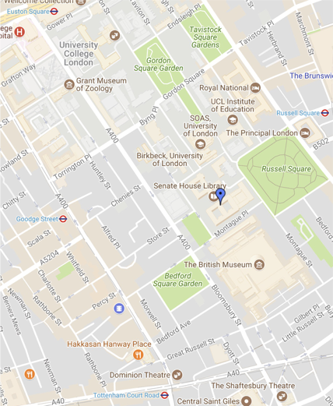

ies.sas.ac.uk

For further information on the range of programmes we offer,   
please visit our website or contact us at:

School of Advanced Study  
Senate House  
Malet Street  
London WC1E 7HU  
United Kingdom

E: iesevents@sas.ac.uk  
T: +44 (0)20 7862 8683

Follow us on:

@IES_London

ies.sas.ac.uk



1. One of our precursors is the University of Leeds workshop, ‘Into the Archive: J. M. Coetzee and His Precursors’ that followed the Beckett conference, ‘Out of the Archive’ at the University of York in 2011. This was before the announcement of the HRC acquisition, and the migration of his manuscripts from Houghton Library, Harvard University. For further details, see: <https://coetzeeandhisprecursors.wordpress.com/abstracts/> <http://www.coetzeecollective.net/articles/2011-06-00.york/jmc-at-york-reading-work-in-progress.html>

   <http://www.hrc.utexas.edu/press/releases/2011/coetzee.html>