  - Welcome to your Degree Programme!
  - BA (Hons) Arts Management Autumn 2019
Dear Students,
As your Programme Director, I am delighted to welcome you to Goldsmiths!
Your degree programme (abbreviated BAAM) is located in the Institute for Creative and Cultural Entrepreneurship (ICCE, pronounced ‘ice’). And so it is also my pleasure to welcome you to ICCE and to BAAM.
A useful resource for new students can be found here on the welcome webpages.
Please have a look through for information about your arrival at Goldsmiths. If you have any questions regarding the upcoming induction week, Keara and Trevor on the administrative team would be more than happy to help. You can contact them at: icce-ug@gold.ac.uk.
As you know, Induction Week starts on 22 September, with a variety of activities at the College level (Goldsmiths), the department level (ICCE) and the programme level (BAAM). Please see the Induction Timetable which is included in your Welcome Pack.
There is no ‘pre-reading’ required for your programme. You may wish to read one of the many books on events management that are available, but it is perfectly sensible to wait until you arrive and read in Goldsmiths’ library. If you are able, consider attending exhibitions, performances, and festivals this summer.
Before you arrive, you will need to select your modules. We will send you more information on this process on Monday 2 September.
I am really looking forward to meeting you!
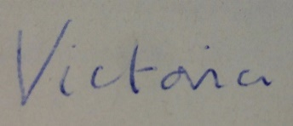
Sincerely yours,
Victoria D. Alexander
Programme Director, BA (Hons) Arts Management

