EHRC Programme Summary: Appendix 1: Attendance Analysis
1. Total Invitees by Sector

3. Total Attendees by Sector

3. Total Invitees by Religion or Belief

4.

4. Total Attendees by Religion or Belief

5. Total Attendance at Dialogues Only by Religion or Belief

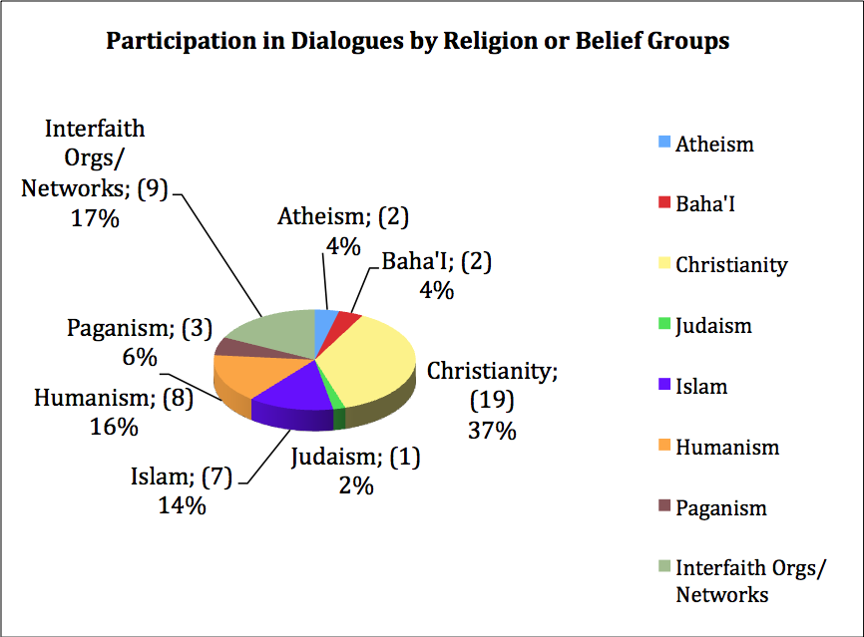

6. Total Attendance at Dialogues Only by Sector

Dialogue 1: Religion & the Public Sphere

7. Attendees by Sector

8. Attendees by Religion or Belief

Dialogue 2: Religion & the Media

9. Attendees by Sector

10. Attendees by Religion or Belief

Dialogue 3: Religious Diversity in the Workplace

11. Attendees by Sector

12. Attendees by Religion or Belief

Dialogue 4: Balancing Competing Interests

13. Attendees by Sector

14. Attendees by Religion or Belief

Summative Conference

15. Attendees by Sector

16. Attendees by Religion or Belief

Analysis by Organisations

When analysed by ‘organisation’, the total number of organizations invited to all of the events is 130. Of those, 75 were represented at one or more of the events.

17. Organisations Attended by Sector
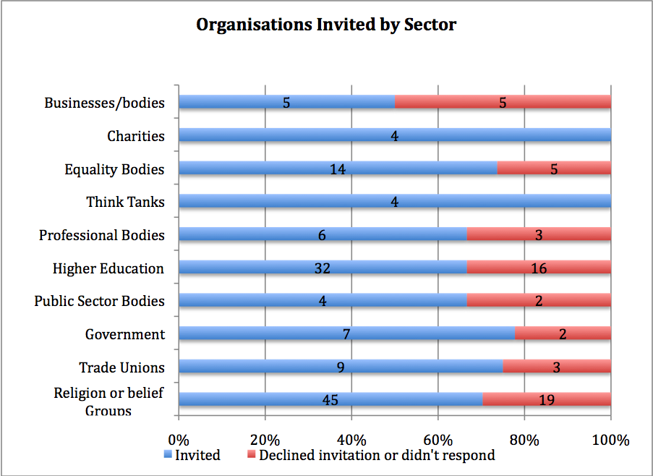
18. Organisations Attended by Religion or Belief

Charts 1 and 2 include all those people who were invites to all of the events.
Charts 3 and 4 include all people who attended all of the events. These totals are cumulative; here people have attended more than one event they have been counted once for each event they attended.
Charts 6 and 7 show the total attendance at the Dialogue events only. They do not include attendance at the Summative Conference. The results are cumulative; where prople attended more than one Dialogue, they have been counted for each Dialogue they attended.

