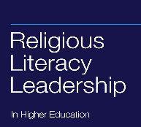
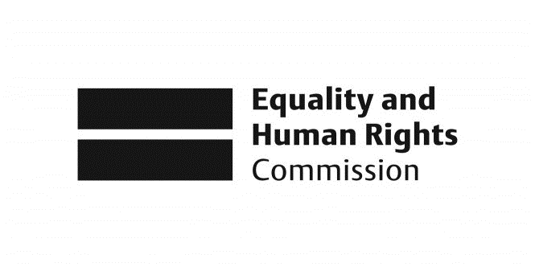

Religious Literacy for Equality in Religion or Belief

Overall Programme Summary

In her meta-review of recent research for EHRC on religion, discrimination and good relations, Professor Linda Woodhead (2011: 6) warns that:

“… there is a risk that so much resource goes into producing new research that what already exists is insufficiently digested and ‘used’, both within the academic community and beyond. There is a danger of reinventing of the wheel, duplicating work, and ignoring what already exists. It is therefore important to consolidate and take stock of all the new information that has been generated by recent research investments.”

That really is the starting point of the EHRC Religious Literacy project, which consists of three sets of activities.

One is an analysis of the research and other work already undertaken by EHRC in this area. In producing this, we heed Woodhead’s warning, citing significant reports and contributions in order to draw out key messages, values and principles which have emerged. By articulating those in one analysis, and in one place, we aim to bring in to focus where research – and EHRC’s research in particular - is at this stage on the question of religion or belief. This analysis is available in the report ‘Religion or Belief: where research points to next’ (Dinham, Francis & Shaw, 2013).

A crucial area of broad consensus arising from that review at the outset is that recent litigation and the frequently intemperate debate that has accompanied it has been unhelpful and is undesirable. So a central aim of this project is to consider the possibilities for a better quality of conversation - rebalancing what Lord Plant has called ‘law’ and ‘jaw’ and establishing dialogue as a first port of call.

This reflects the ‘religious literacy’ approach underpinning our work. Like many things in this field, the term is debated. But it is possible to identify some points of consensus as a basis for a working definition:
- Religions deserve to be articulated publicly, not only so their positive aspects are acknowledged and engaged with, but also so they can be criticised constructively and risks identified and addressed.
- Religious literacy has the potential to mediate differences and to broaden horizons. It can also challenge any attempt to close down debates with conversation-stopping certainties and absolutes.

In searching for a definition, the Religious Literacy Leadership Programme has suggested this:
“…having the knowledge and skills to recognise religious faith as a legitimate and important area for public attention, a degree of general knowledge about at least some religious traditions, and an awareness of and ability to find out about others” (Dinham & Jones 2010).

It proposes that the purpose is:
“…to avoid stereotypes, respect and learn from others and build good relations across difference. In this it is a civic endeavour rather than a theological or religious one, and seeks to support a strong, cohesive, multifaith society, which is inclusive of people from all faith traditions and none in a context that is largely suspicious and anxious about religion and belief.” (Dinham & Jones 2010)

The overall aim can be summarised as seeking to inform intelligent, thoughtful and rooted approaches to religion and belief – whatever one’s own stance - that countervail unhelpful knee-jerk reactions.

On this basis, we explore the possibility that law – which has tended to be prominent in public debate about religion or belief - might be better contextualised as a backstop guaranteeing the rights that are enshrined, but not necessarily being seen as the first or only port of call.

We put this forward as the normative starting point of the project – but as one which is open to contestation. Of course not everybody does see it that way. The central aim is to explore and articulate the variety of ways in which stakeholders do and would wish to approach religion or belief.

In doing so, we need to note that neither religion nor belief are simple categories. Nor are they very stable. What’s more, they are very often at the same time both highly personal and deeply felt, and significantly publicly expressed. This can easily lead to dialogues producing more heat than light. The question is whether it is worth the attempt to listen and discuss, or is it better to rely on law, turning to it when interests compete or clash?

Our religious literacy - and our approach to religion or belief - are probably one of the pressing issues of our time. Religions and beliefs persist despite the deep-rooted secular assumptions of the last century. Billions of people around the world remain religious; millions are in the UK; migration and globalisation increasingly expose us all to encounter with difference and diversity in religion and other beliefs at work, at leisure and increasingly at home. Yet we have largely lost the ability for a good quality of conversation about religion or belief (see Dinham 2012).

The landscape of religion and belief is at the same time harder than ever to define. Society continues to be Christian, secular, more plural and less formal: more and more of us believe nothing; or something – but we’re not sure what; or many things, as in Jewish atheism or Christian Hinduism. Many people hold spiritual, non-creedal, non-organisational beliefs. Others have non-religious beliefs which are deeply important to them, as in humanism, secularism and environmentalism.

So a concern driving the project is that a turn in one direction to the over-simplicity of religious ‘traditions’ or ‘beliefs’, and in the other to a law which ‘settles’ rights about them, will likely fail to engage with this complex reality. We invite anyone with an interest to engage with this debate.

The written reports and materials emerging from the project are intended as a basis for exploring effective approaches and alternatives. They are intended to articulate what has been said in the dialogues themselves and thereby to represent the fullest range of approaches and starting points we’ve heard.

We did not expect consensus, nor have we found it. But we are able to offer these reports as a framework of continuity and difference to aid people’s thinking for the future. We invite readers to engage accordingly.

Methodology for the Dialogues

Each dialogue theme was identified on the basis of analysis of previous research work commissioned by the EHRC. We drew out the key messages and contests and translated them in to the thematic dialogues which followed. These were:
- Religion and Belief in the Public Sphere
- Religion and the Media
- Religion and Belief in the Workplace and Service Provision
- Balancing Competing Interests

Participants were selected in a purposive overall sample by the project team and partners at EHRC with the aim of involving the following:
  - People of traditional faiths
  - People from non-traditional faith backgrounds
  - People of non-religious belief
  - People of no religion or belief
  - Employer groups, including campaign and lobby groups
  - Trades Unions
  - Small and Medium Business (SME) umbrella bodies

A total of 180 individuals were identified and invited to nominate themselves or a closely equivalent colleague to any of the dialogues in order of preference. It was made clear that attendance would be determined by the project team on the basis of achieving a balance between the groups identified above. Not everybody would be able to attend everything they might indicate a preference for.

A breakdown of those people invited is as follows:

There follows an analysis of participation by sample group. Note that the figures are cumulative for all the dialogue events, so where a member of one organisation attended all four events, they were counted four times. Likewise if two people from the same organization attended an event, they were both counted.

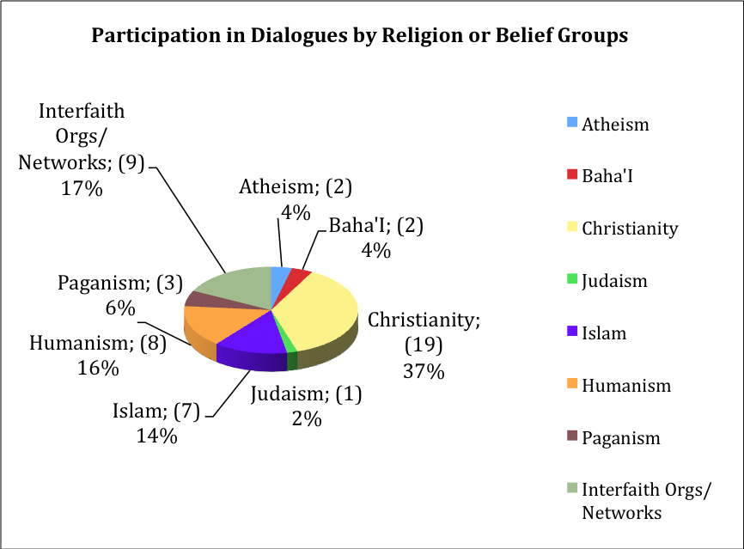
For a comprehensive analysis of participation please see appendix 1. This includes an analysis of attendance by religion or belief and by sector for each individual Dialogue and analysis of the types of organisations invited to all the events compared alongside participation.

Each dialogue began with an introduction to the project and its aims, and a setting out of the religious literacy approach. They then included short intensive presentations by leading thinkers to stimulate and provoke thought and dialogue.

Participants were then divided in to small groups of approximately 7-10 each. Following café dialogue methodology, each group discovered a talking point or question on their table (derived by the project team from the analysis of earlier work) and were asked to use this as a basis for dialogue. They were given 20 minutes per question and then rotated to a new table and question, within the same group. This was repeated three times. Each discussion had a facilitator (who stayed with their table, not with the group) and a note-taker, who travelled with the group.

Following the sub-groups, a whole-group plenary then worked together to bring together the discussions. This was facilitated and noted by a member of the project team.

A report of each dialogue is available via the project website at www.religiousliteracy.org

Summative Conference

It has always been intended that the project would learn directly from the sample group in each dialogue and would subsequently share its findings much more widely. A key mechanism for doing so is a summative conference (held in London on 18 April 2013) which brought together the participants from all of the dialogues to work on developing action points for taking religion or belief work on. This will underpin EHRC’s forward planning, including as a basis for ongoing public engagement.

A report of the conference is also available via the project website.

In a paper given at the University of Bristol, Religion in a Liberal State, Raymond Plant, Bristol Symposium, May 2010.
Note that the figures correspond to individuals. For a breakdown by organisation, see Appendix 1.

