INCIDENT / ACCIDENT / NEAR MISS REPORT FORM
First aider / reporting person to complete:
☐Incident ☐Accident ☐Near Miss  Name of Injured Person:  Address:  Age:  Phone number:  ☐Staff ☐Student ☐Member of public/visitor  Department: |  |  | Name of reporting person:  Are you a first aider: ☐Yes ☐No  Department:  Phone number:
Details of event
Location of Incident/ Accident:
Date:
Time:
Description of event:
Description of first aid given:
Was the injured person taken to hospital? ☐Yes ☐No
Was any property damaged? ☐Yes ☐No
Names, address and contact phone number of witnesses:
1:
2:
PLEASE ENSURE ANY INJURY INFORMATION IS RECORDED OVER THE PAGE
Injury sustained? ☐Yes ☐No
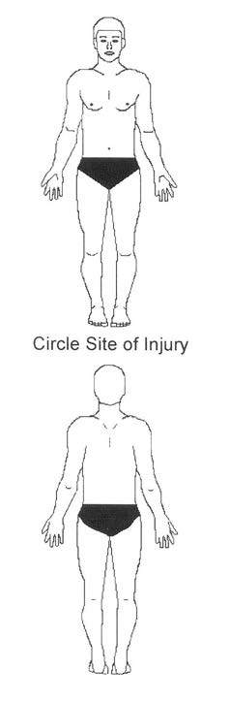 | Nature of Injury  ☐Abrasion  ☐Absorption  ☐Bitten  ☐Bruise  ☐Burn  ☐Choke  ☐Crush  ☐Cut  ☐Dislocation  ☐Electric shock  ☐Fracture  ☐Hearing damage  ☐Illness/medical  ☐Infection  ☐Inhalation  ☐Irritation  ☐Multiple injuries  ☐Poison  ☐Puncture  ☐Rash  ☐Scald  ☐Seizure  ☐Sprain  ☐Strain  ☐Not Known  ☐Potential Injury | Part of Body  ☐Abdomen  ☐Ankle  ☐Arm  ☐Back  ☐Chest  ☐Elbow  ☐Eye  ☐Finger  ☐Foot  ☐Forehead  ☐Hand  ☐Head  ☐Hip  ☐Internal  ☐Knee  ☐Leg  ☐Mouth  ☐Multiple areas  ☐Neck  ☐Nose  ☐Shin  ☐Shoulder  ☐Thigh  ☐Thumb  ☐Toe  ☐Wrist  ☐Not Known/Other |  | Method of injury  ☐Asphyxiation  ☐Assault - physical  ☐Assault – verbal  ☐Bite/sting  ☐Burn  ☐Contact moving machine  ☐Contact sharp object  ☐Contact stationary object  ☐Electric shock  ☐Explosion  ☐Exposure to substance  ☐Fall less than 2m high  ☐Fall more than 2m high  ☐Fire  ☐Flooding  ☐Manual handling  ☐Road traffic  ☐Self-harm  ☐Slip and trip (wet/slippery)  ☐Slip and trip (uneven)  ☐Sports injury  ☐Struck by falling object  ☐Struck by moving machine  ☐Other
This form must be completed and sent to the Health & Safety Office within 24hrs
Signature of person reporting: Date:

Signature of injured person: Date:

Signatures confirm that the information given accurately records the event.
Email to healthandsafety@gold.ac.uk
Telephone enquiries 07894 622 115

